**Assignment 6**

**Write a report on Storage as a Service (Staas) using Google Drive**

1. **Introduction to Google Drive:**

Google Drive is a cloud-based file storage and synchronization service developed by Google. Launched in 2012, it allows users to store files in the cloud, synchronize files across devices, and share files with others. Google Drive provides users with a secure and accessible platform to store various types of files, fostering collaboration and ease of access.

1. **Sharing Feature in Google Drive:**

One of the key features of Google Drive is its robust sharing capabilities. Users can share files and folders with specific individuals or groups, controlling access permissions such as view-only or editing rights. The collaboration features facilitate real-time editing and commenting, enhancing teamwork and communication among users. The link-sharing option enables easy distribution of files to a broader audience.

1. **Demonstrate Uploading and Storage on Google Drive (My Drive):**

Uploading and storing files on Google Drive is a straightforward process. Users can simply drag and drop files or use the "New" button to upload documents, images, or other entities. Google Drive automatically organizes uploaded content in the user's "My Drive," providing a centralized location for easy retrieval. The storage capacity can be expanded through subscription plans, offering flexibility based on user needs.

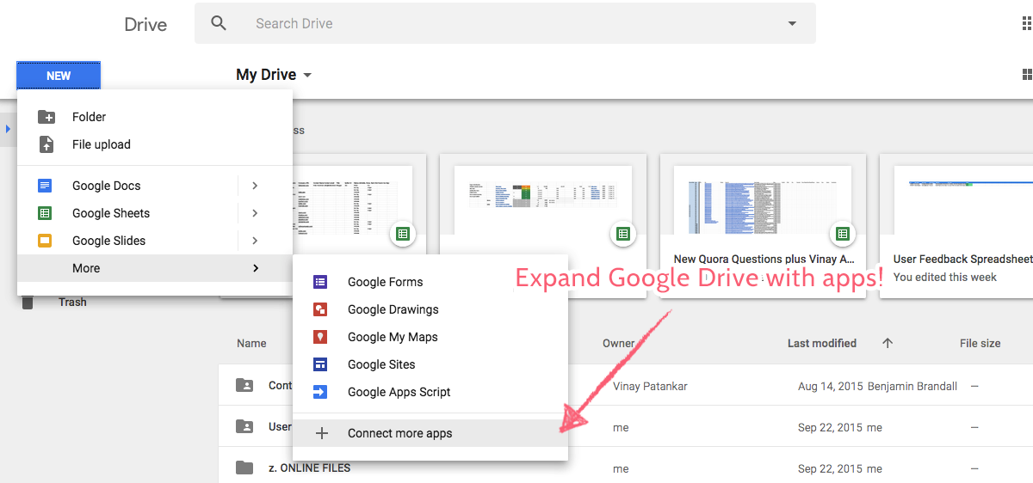

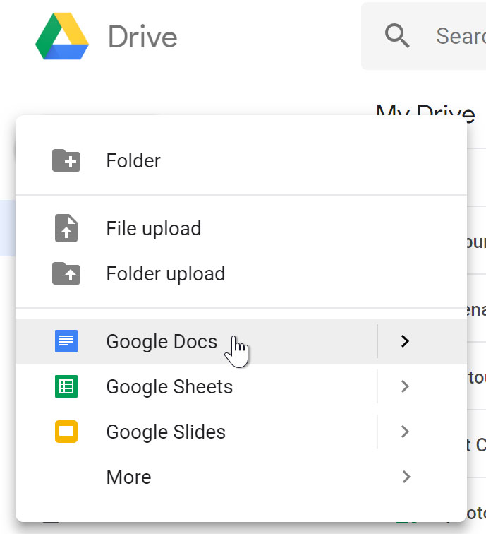

1. **Sharing Policies:**

Google Drive offers customizable sharing policies, allowing users to manage access levels and security. Users can set sharing settings at the individual file or folder level, controlling who can view, edit, or comment on their content. Additionally, advanced sharing options enable link expiration, password protection, and restricting access to specific users with Google accounts.

1. **Google Drive Tools and Options:**

Google Drive provides a range of tools and options to enhance user experience. Features such as Google Docs, Sheets, and Slides enable collaborative document editing in real-time. Version history allows users to track changes and revert to previous states. The powerful search functionality helps users quickly locate files, and the offline mode ensures accessibility even without an internet connection. Google Drive also integrates with other Google Workspace applications, providing a seamless experience across the productivity suite.

In conclusion, Google Drive's Storage as a Service (STaaS) model offers a versatile and user-friendly platform for file storage, sharing, and collaboration. Its intuitive interface, robust sharing policies, and integration with productivity tools make it a valuable solution for individuals and businesses seeking efficient cloud-based storage and collaboration capabilities.